QOU International Conference on Information and Communication Technology
Author Name
Department, Faculty
University, City, Country
Email Address
Abstract:
An abstract of 200-300 words.

Keywords— Conference, Guidelines, ICT.

1. Introduction
This is a guideline for the QICICT conference.
Equation (1) demonstrates the relationship between the duty cycle, the pulse width, and the period:
$Duty_Cycle=\frac{Pulse_Width}{Period}×100\%$ … (1)
Authors may check the guidelines attached with this template.
The remainder of the paper is organized as follows. Section II introduces a literature review. Section III introduces the the developed environment. While section IV introduces the results and practical scenarios, section V concludes the paper.

2. Literature Review
This section introduces a literature review.

3. System Architecture
The objective of this paper is to design and …

3.1 The Development Board
This subsection describes the … . As shown in Figure 1, the … .
An example of a conference paper is described in (Guo et al., 2019) and (Saragih et al., 2020). An example on a website is illustrated in (Intel FPGAs, 2021), and an example of a journal paper is shown in (Svilainis, 2012) and (Yoo et al., 2007).
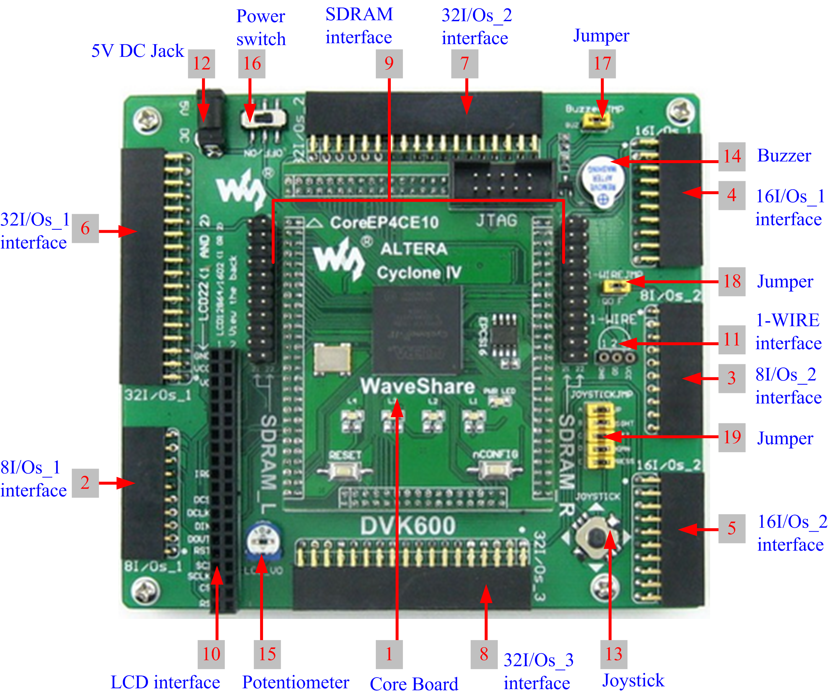
Fig. 1.
An example on a figure.
The … with the features shown in table 1.
Table 1:
Features of XYZ
Feature | Value
System Frequency | 50MHz
Core Voltage | 1.2V
Inputs/Outputs | 180
Logical Elements (LEs) | 10320
RAM | 414kB
Programming Interface | JTAG

The next subsection describes the environment … .

3.2 Environment Design
This subsection describes the design .

4. Results and Practical Scenarios
The.

5. Conclusion
The paper describes a successful implementation and synthesis of … .
References
- Guo, X. Y., Wan, G. C., & Tong, M. S. (2019, December). An Intelligent Control System of Music Rhythms by RGB-LED Lamp. In 2019 Photonics & Electromagnetics Research Symposium-Fall (PIERS-Fall) (pp. 1622-1627). IEEE. https://doi.org/10.1109/piers-fall48861.2019.9021892.
- Intel FPGAs, C. (2021). Cyclone® IV FPGAs Devices - Intel® FPGA. Retrieved 14 March 2021, from https://www.intel.com/content/www/us/en/products/programmable/fpga/cyclone-iv.html.
- Saragih, Y., Dermawan, R. D., Latifa, U., & Ming, C. C. (2020, June). Smart Angklung 2 Octave. In 2020 3rd International Conference on Mechanical, Electronics, Computer, and Industrial Technology (MECnIT) (pp. 276-281). IEEE. https://doi.org/10.1109/mecnit48290.2020.9166645.
- Svilainis, L. (2012). Comparison of the EMI performance of LED PWM dimming techniques for LED video display application. Journal of display technology, 8(3), 162-165. https://doi.org/10.1109/jdt.2011.2175362.
- Yoo, H., Kim, J. H., & Sul, S. K. (2007). Sensorless operation of a PWM rectifier for a distributed generation. IEEE Transactions on Power Electronics, 22(3), 1014-1018. https://doi.org/10.1109/tpel.2007.897094.

